院/系__________专业/班级______________姓名 _______________学号_______________
第五章 染色体畸变
Chromosome Abberation
1．(From H4e, 13-8) A series of chromosomal mutations in Drosophila were used to map the javelin gene that affects bristle shape, and henna, which affects eye pigmentation. Both the javelin and henna mutations are recessive. A diagram of region 65 of the Drosophila polytene chromosomes（多线染色体）is shown here.
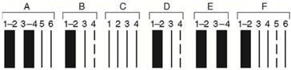
The chromosomal breakpoints for six chromosome rearrangements are indicated in the following table. (For example, deletion A has one breakpoint between bands A2 and A3 and the other between bands D2 and D3.)
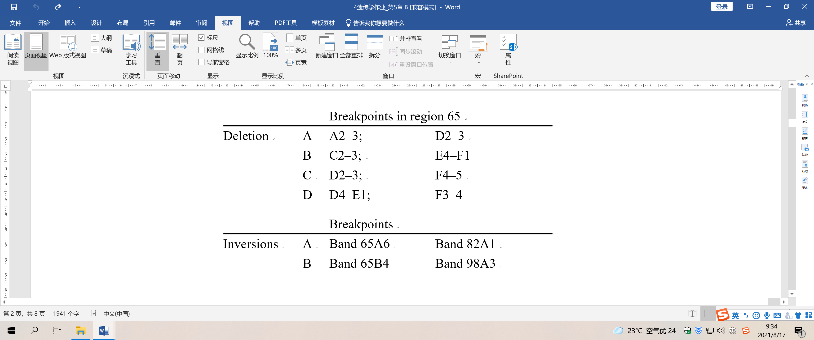
Flies with a chromosome containing one of these six rearrangements (deletions or inversions) were mated to flies homozygous for both javelin and henna. The phenotypes of the heterozygous progeny (that is, rearrangement / javelin, henna) are shown here.
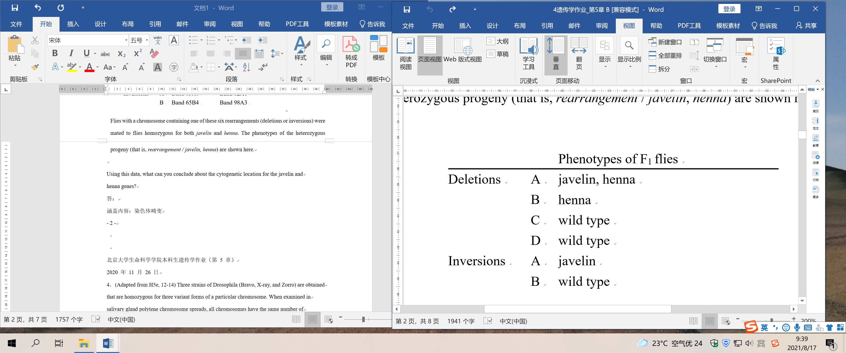
Using this data, what can you conclude about the cytogenetic location for the javelin and henna genes?
答：

2．(Adapted from H5e, 12-14) Three strains of Drosophila (Bravo, X-ray, and Zorro) are obtained that are homozygous for three variant forms of a particular chromosome. When examined in salivary gland polytene chromosome spreads, all chromosomes have the same number of bands in all three strains. When genetic mapping is performed in the Bravo strain, the following map is obtained (distances in map units).
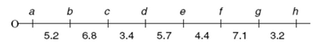
Bravo and X-ray flies are now mated to form Bravo/ X-ray F1 progeny, and Bravo flies are also mated with Zorro flies to form Bravo/Zorro F1 progeny. In subsequent crosses, the following genetic distances were found to separate the various genes in the hybrids:
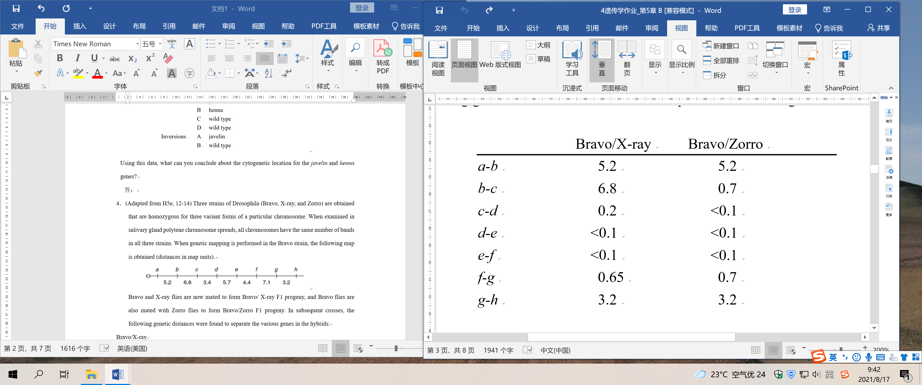

a. Write down the relative order of genes a through h in the X-ray and Zorro strains. Do not show distances between genes.
b. In the original X-ray homozygotes, would the physical distance between genes c and d be greater than, less than, or approximately equal to the physical distance between these same genes in the original Bravo homozygotes?
c. In the original X-ray homozygotes, would the physical distance between genes d and e be greater than, less than, or approximately equal to the physical distance between these same genes in the original Bravo homozygotes?
答：

3．(Adapted from H5e, 12-16) Suppose a haploid yeast strain carrying two recessive linked markers his4 and leu2 was crossed with a strain that was wild type for HIS4 and LEU2 but had an inversion of this region of the chromosome as shown here in blue (grey in black and white print).
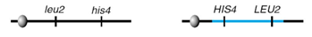
Several different kinds of crossover events could occur during meiosis in the resulting diploid. For each of the following events, state the genotype and phenotype of the resulting four haploid spores. Do not consider crossover events between chromatids attached to the same centromere.
a. a single crossover between the markers HIS4 and LEU2
b. a double crossover involving the same chromatids each time, where both crossovers occur between the markers HIS4 and LEU2
c. a single crossover between the centromere and the beginning of the inverted region
答：

4．(From H5e, 12-18) During ascus formation in Neurospora, any ascospore with a chromosomal deletion dies and appears white in color. How many ascospores of the eight spores in the ascus would be white if the octad came from a cross of a wild-type strain with a strain of the opposite mating type carrying
a. a paracentric inversion, and no crossovers occurred between normal and inverted chromosomes?
b. a pericentric inversion, and a single crossover occurred in the inversion loop?
c. a paracentric inversion, and a single crossover occurred outside the inversion loop?
d. a reciprocal translocation, and an adjacent-1 segregation occurred with no crossovers in the translocated regions?
e. a reciprocal translocation, and alternate segregation occurred with no crossovers in the translocated regions?
f. a reciprocal translocation, and alternate segregation occurred with one crossover in the translocated regions (but not between the translocation breakpoint and the centromere of any chromosome)?
答：

5．(From H5e, 12-20) In Drosophila, the gene for cinnabar eye color is on chromosome 2 and the gene for scarlet eye color is on chromosome 3. A fly homozygous for both recessive cinnabar and scarlet alleles (cn/cn; st/st) is white-eyed.
a. If male flies (containing chromosomes with the normal gene order) heterozygous for cn and st alleles are crossed to white-eyed females homozygous for the cn and st alleles, what are the expected phenotypes and their frequencies in the progeny?
b. One unusual male heterozygous for cn and st alleles, when crossed to a white-eyed female, produced only wild-type and white-eyed progeny. Explain the likely chromosomal constitution of this male.
c. When the wild-type F1 females from the cross with the unusual male were backcrossed to normal cn/cn; st/st males, the following results were obtained:
Diagram a genetic event at metaphase I that could produce the rare cinnabar or scarlet flies among the progeny of the wild-type F1 females.
答：

6．(From H5e, 12-22) A proposed biological method for insect control involves release of insects that could interfere with the fertility of the normal resident insects. One approach is to introduce sterile males to compete with the resident fertile males for matings. A disadvantage of this strategy is that the irradiated sterile males are not very robust and can have problems competing with the fertile males. An alternate approach that is being tried is to release laboratory-reared insects that are homozygous for several translocations. Explain how this strategy will work. Be sure to mention which insects will be sterile.
答：

7．(Adapted from H4e, 13-30) The EcoRI restriction map of the region in which a coat-color gene in mice is located is presented in the following. The left-most EcoRI site is arbitrarily labeled 0 and the other distances in kilobases are given relative to this coordinate. Genomic DNA was prepared from one wild-type mouse and 10 mice homozygous for various mutant alleles. This genomic DNA is digested with EcoRI, fractionated on agarose gels, and then transferred to nitrocellulose filters. The filters were probed with the radioactive DNA fragment indicated by the “purple” (grey in black and white print) bar, extending from coordinate 2.6 kb to coordinate 14.5kb. The resultant autoradiogram is shown schematically.
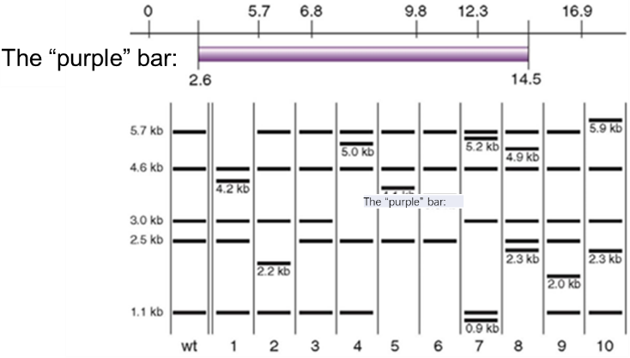
Assume that each of the mutations 1–10 is caused by one and only one of the events on the following list. Which event corresponds to which mutation?
a. a point mutation exactly at coordinate 6.8
b. a point mutation exactly at coordinate 6.9
c. a deletion between coordinates 10.1 and 10.4
d. a deletion between coordinates 6.7 and 7.0
e. insertion of a transposable element at coordinate 6.2
f. an inversion with breakpoints at coordinates 2.2 and 9.9
g. a reciprocal translocation with another chromosome with a breakpoint at coordinate 10.1
h. a reciprocal translocation with another chromosome with a breakpoint at coordinate 2.4
i. a tandem duplication of sequences between coordinates 7.2 and 9.2
j. a tandem duplication of sequences between coordinates 11.3 and 13.3
答：

